The Digital Design of Photography:
Digital Photographic Manipulation and Its Representation of Reality
Ariel Body
MA University of Ulster
arielbody@gmail.com

Abstract:
This paper will explore the topic of designing photographic representations of reality from digital artifice, and contemplate the notions it inspires about the correlation between the photograph and truth in the digital age. If a photograph typically stands as evidence of something’s existence, is it possible to create a photo of a memory or a dream? This paper will explore this idea through a discussion of relevant techniques and practical examples of digital manipulation as a means of recreating reality.
The key theme of the paper will surround the use of computer generated imagery (CGI) in place of and as photography, exploring the idea of blurring the boundaries between the ‘real’ world and the ‘digital’ world by recreating snapshots of memories using 3D computer modelling and photorealistic rendering in conjunction with photography. Considering that, arguably, manipulation in one form or another is found in nearly all photographs anyway – from pre-shutter staging to a variety or post-processing techniques – this particular digital manipulation technique offers a unique perspective on designing photography. The paper will seek to inspire a shift in thinking about photography from something that captures the present to something that recreates the past using modern digital manipulation techniques that push the boundaries of the definition of the photograph and what it represents.

1. Introduction
To fully understand the importance of the debate around photography’s realism, it is necessary to have an understanding of the role of photography in culture, along with its history and indexical representation of society. The photograph has long represented evidence of something, as to take a photograph was understand that the object physically existed. You could touch it, smell it, and move it. When digital methods first emerged in the late 20th century, where the photograph used to be a very finite chemical process, it became something that was very much flexible. Digital pixels could be moved and reality could be distorted with the click of a button.
The use of computer generated imagery in particular represents a new way of telling that draws its roots from the believability of real life photography. In many instances, it allows the photographer to tell a story that is just as real – to represent the imagined or remembered in a true to life manner. It is possible to create, erase, tweak, and manipulate until the image designed is exactly what is imagined. In many ways, it has put photography’s once decisive moment in a continuous state of flux.
The fusion of these two realities (i.e., ‘real’ and ‘digitally artificial’) therefore represents a new avenue of creative output by embracing the effect of the digital revolution to form a new means of visual communication. It is a method that relies on the familiarity of photography and enhances it with the fairytale of the digital. Visual qualities aside, the output represents an embrace of modern digital techniques, and in many ways represents Marshall McLuhan’s observation that ‘the medium is the massage’ (McLuhan and Fiore, 1967), suggesting that this collaboration and output are more of a commentary on today’s increasingly digital culture and its effect on photography, than they are about the actual content.

So while the definition of photography is perhaps shifting from something very concrete to something in a digital state of flux, the photograph itself still remains the same. From the social constructs to the look and feel of real life, a photograph – even one that heavily relies on CGI – is still a representation of someone’s reality. Yes, its creation is one derived from digital pixels as opposed to tangible objects, but arguably, it still depicts something that could exist, perhaps, or recreates something that once did exist.
The growth in popularity of digital manipulation then represents a new trend in visual communication and simultaneously raises questions as to the new digitally-infused photography’s correlation to reality. This paper therefore seeks to inspire a shift in thinking about photography in light of these digital advances. Manipulation and computer generated imagery no doubt represent powerful tools that can be used to expand the field of photography, but is its product still believable? Can it be used to believably visualize memories or imagined realities? This paper will examine thoughts within this discussion and highlight modern day practitioners whose work is effectively influenced by these digital methods.
2. Image Perception
To understand the basic psychology behind photography’s believability, it is helpful to have an understanding of image perception and how meaning is gained from looking at an image. Some theories suggest that communication from a piece of graphic design is understood by the viewer based on their perception of the relationship between elements within the work. (Jamieson, 2007) When applied to photography, an understanding of this concept can increase one’s ability to strategically design photographs that more explicitly represent communication or an intended concept.
Beyond that, this theory opens up the opportunity to create work that not only tells stories, but also encourages the viewer to fill in gaps based on their understanding. This would mean that, while there is an underlying message, the importance of a particular piece also lies in the fact that viewer brings with them their knowledge, history, personal perception, and therefore understanding and meaning from the image.

The root of the viewer’s understanding and belief of photography can perhaps be traced to their previous experience and interaction with the medium. Because a large percentage of the population are familiar with the concept and process of photography, more specifically because they have personal experience with taking and being in photos, they are more likely to interject their own ideas of realism into a particular piece of photo-realistic visual communication. Research suggests that when confronted with a photograph, the human brain will instinctively react by assuming the image is reality, and therefore impose meaning based on personal experience. Likewise, it can be argued that the viewer becomes somewhat of a critic, by attempting to place themselves within the scenario in which the photo was taken. (Feldman, 1987)

2.1 Photographic Manipulation
It is perhaps because of this that photography therefore comes with a certain sense of belief in its reality. With digital manipulation – from the most basic use of Photoshop to works utilizing synthetically designed photorealistic computer generated imagery – is this relationship between photography and reality lost? Furthermore, is it possible to create a photograph of something imagined or remembered?

Historically, it can be said that nearly all photographs are, in essence, manipulated. Take for example, 20th century photographers Jeff Wall, Gregory Crewdson, and Philip Lorca diCorcia, all of whose work rely heavily on the physical creation of a narrative within a photograph. From hiring entire film crews to building sets to selecting a camera angle, these photographers are manipulating their photos to achieve their intended outcome. Granted, they are doing it within the ‘real world’ using items and beings that exist and are made of atoms, but the effects of that manipulation are arguably no less drastic than the use of digital methods.

In her book On Photography, Susan Sontag (1978) asserts that the use of photography has long carried with it the notion of being real, and that while a photo may distort that reality, it still implies that the subject either does or did exist. Arguably, this is not necessarily a true notion, as even before the realm of digital possibilities was unleashed on photography, manipulation was present as even traditional analog photographers attempted to redesign their perception of reality through various means of fabrication. If we have come to accept such staged photography as "real", embracing CGI infused photography is really not that much of a leap; it merely shifts one from questioning: “Is it true or false?” to “Is it real or not?”
Who’s to say then, that digitally assisted recreations of memories as fairytale or imagined versions of a particular surrounding are any more of a stretch from reality than any other form of interpretation?

2.2 Thomas Demand
The photographer Thomas Demand explores similar notions in his work, in which he builds conceptual reconstructions of historical or personal memories with paper, then photographs the pieces to create a somewhat eerie representation of the actual event. In an article written about his work, Roxana Marcoci (2004) further explores this idea of photography representing something constructed, not necessarily already existing or natural. While it is arguable that all photographs – or forms of art in general – are the artist’s interpretation, Marcoci (pp.9-27) explains that, in Demand’s work particularly, there is an apparent ‘awareness that activities related to the act of truth-telling, such as adjusting, abbreviating, omitting, padding, and falsifying, are all intrinsically linked to the process of interpretation’.

For Demand, his methods of retelling are symbolic of his interpretation and representation of those particular realities – arguably no different than a documentary photographer selecting a neutral angle or a portrait photographer using dramatic lighting to invoke a particular emotion. Similarly, Susan Sontag (1978, pp.165) asserts that ‘…photographs are not so much an instrument of memory as an invention of it or a replacement.’ Essentially, with each way of telling, come new avenues of photographic meaning.

3. The Design of Photography (CGI)
To design photographs using computer generated imagery is to bring into existence realities that are previously only imagined. The process involves digitally sculpting various artifacts, creating and assigning materials to those creations, and then rendering these elements to create a photorealistic outcome. While this process relies heavily on computer software, it also strongly involves a knowledge of fundamental photographic principals. This includes the use of photographs of materials and textures applied to objects, knowledge and application of lighting techniques, and even a visual understanding of how to frame a scene effectively.
Once the process is complete, the digitally constructed reality can then be merged with real life photography to seamlessly create a product that, in essence, blurs the two realities into a new one entirely.
3.1 Real vs. Imagined
To illustrate this point of artificial realism further within the context of CGI, we can compare the work of traditional photographer Jeff Wall with an image from Alex Roman utilizing CGI methods.
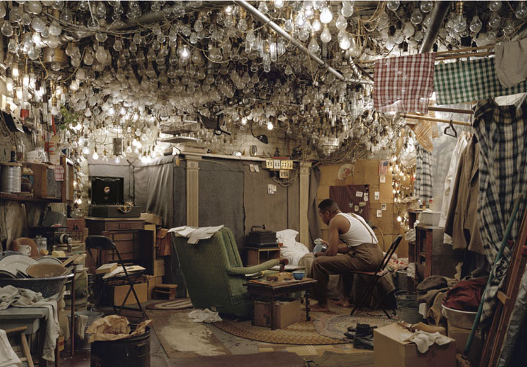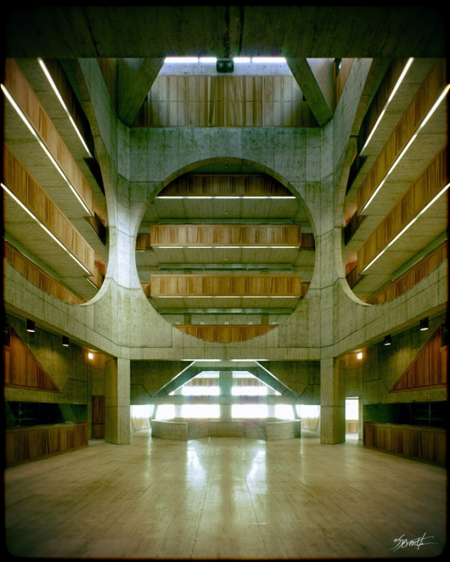
Fig.1 Jeff Wall, “The Invisible Man”, 2000 Fig. 2 Alex Roman, Exeter Academy Library, 2008

In Wall’s photograph “The Invisible Man”, the entirety of the content existed at some point and took up physical space. However, the room was created specifically for the sole purpose of taking the photograph and was based on a fictitious novel from history. In Roman’s Phillips Exeter Academy Library image, the location was modeled using CGI to look exactly like the existing building in New Hampshire. While the version of the library seen in Roman’s image was created completely of digital ones and zeros, it mimics something that still exists and represents reality. However, even though Wall’s image was not digitally created in any way, the content within does not still exist within our everyday reality. Where it seems like there is a drastic difference in the output of the two techniques, they are actually largely the same; they are both cultural constructs.

3.2 Photography and the Photograph
Within this debate, it is also important to distinguish between the difference in photography and its product, the photograph. In an article written for the Journal of Media Practice, photomedia artist and professor Yon Marsh (2009) introduces the idea of differentiating between traditional and digitally manipulated images, by suggesting a new name for the latter – the ‘phototrix’. The benefits of this, as Marsh states, would come in the form of ‘replacing the term photograph and its history bound up with silver and the past’ (pp. 271), almost standing as a label to embrace the digital manipulation process.

In the context of this paper, the ‘phototrix’ then becomes the product of using CGI and photography together. In many ways, this collaboration more importantly highlights the relationship than the outcome. Marsh’s introduction of a new term across a broad scope is perhaps idealistic and unrealistic, but the point it makes regarding the definition of the photograph is relevant. The product – the photograph or phototrix – remains the same: a photorealistic visual representation of someone or something. The process used to derive this product, however, can vary drastically, and where Marsh’s term acknowledges this digital influence as a new breed of its own, its cultural importance and essence of representation remain the same as a traditional photograph. Ultimately, it is more of a commentary on how the act and process of photography itself has evolved in modern day culture to include an embrace of digital technology and integration.
3.3 Richard Kolker’s CGI Photography
To further illustrate the capability of computer generated imagery to more accurately represent reality, we can look at photographer Richard Kolker, whose work is almost exclusively created using CGI. His synthetic yet photo-realistic images seek to portray reality through the means of 3D computer modeling.

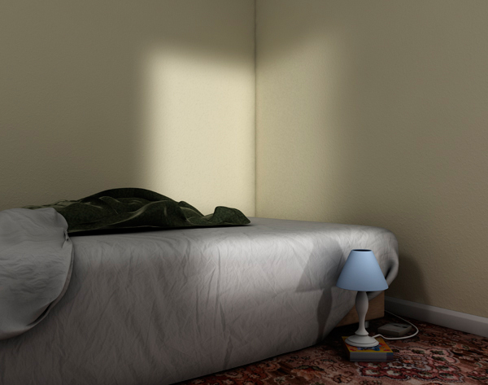
Fig. 3 Richard Kolker, “Logging On” from The Game series, 2008

In 2008, he completed a series entitled “The Game” where he recreated the living spaces of gamers using CGI, which was not only visually interesting, but also theoretically on the level that he used the very means of creation to make a statement about the life and social norms of these gamers. The realities of the places he portrayed were based on real life, but constructed completely from digital artifice in a believable fashion. I would argue that the photographic story he told was strengthened immensely by his method of recreation, visually alluding to the story and reality of the lives of the very people he was trying to portray. While Kolker’s work is largely computer generated, it is very much based on photographic theory and principals, and is just one example of how the means of creation can strengthen photographic work both visually and conceptually. Kolker’s process of photography relied heavily on the use of CGI, but his ultimate representation is still a photograph, a single frame narrative depicting a relatable real world scenario.

3.4 The Benefits of Computer Generated Imagery
The benefits of using digital manipulation and CG methods are also substantial and important to consider. Where a location may not be available, or a prop not exact, CGI flourishes as a problem-solving tool. While it is often difficult to drastically change physical props or locations without exorbitant costs, you can manipulate pixels of CGI based elements to perfect the image for the desired outcome. Furthermore, creating elements within a digital reality expands the possibilities nearly to a point where if you can imagine it, you can create it. This is a skill that can be used within many photographic outlets, and photographers currently exploring methods in this area have been successful both within an advertising and fine art context.

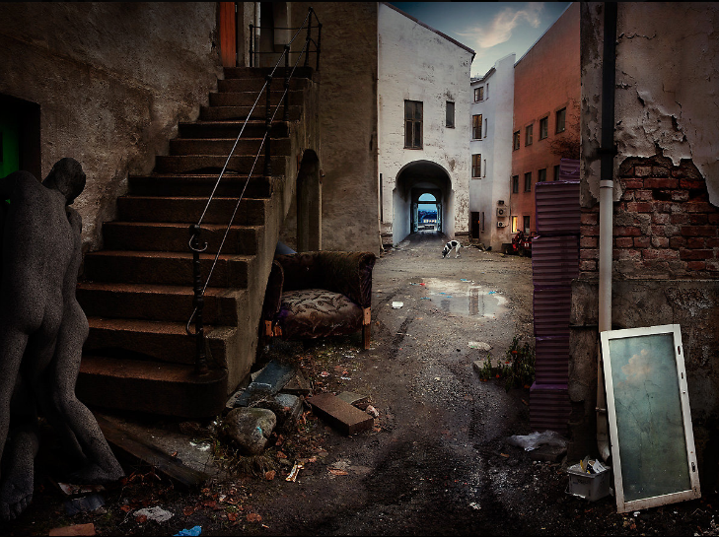
Fig. 4 Fredrik Odman, Oslo Project, 2010 Fig. 5 John Offenbach, Travelers Insurance Ad, 2009
Photographer Fredrik Odman, for example, creates work that truly fuses the real and digital realms into a new reality, creating stunningly detailed images with strong narrative qualities. His work on the series “Oslo Project” visualizes scenes that would otherwise have been difficult to recreate in real life. Similarly, advertising photographer John Offenbach has successfully transferred skills such as these within the corporate and advertising realm. His work indeed utilizes the strengths and benefits of digital methods, exaggerating concepts and details to make witty or otherwise difficult points, as seen in the above image from his work on the Travelers Insurance advertising campaign. Both are successful examples of using digital manipulation and computer generated imagery in an effective and photorealistic way. Essentially, blurring the boundaries between the ‘real’ world and the ‘digital’ world to create a strengthened and cohesive outcome.

4. Digital Perception
While it is easy to highlight benefits and examples of using digital manipulation techniques and CGI, in light of the rise of its popularity it is important to consider how this shift also affects the viewer’s foundational perception of the photographic reality. If photographs become something heavily digitally designed, will they still carry the impact and believability that they once did? Is it even important that they do?

If we have an understanding of photography’s link with realism, that it is essentially based on one’s experiences, we can use that to strengthen the affect of works utilizing computer generated imagery as, and in conjunction with, photography.
As discussed previously, photographs have historically had a very social function in representing and recording events and stories. Since the National Geographic incident with the moving of the Pyramids of Giza in 1982, there has been a certain air of scepticism around manipulation, and while it is certainly possible to find examples where it is used as a tool to mislead or deceive, it should also be seen as a powerful tool to empower photographers to find new and innovative means of photographic storytelling.

4.1 Experience with Digital Reality
The rise of digital photography and methods also carried with it a massive growth in accessibility, and because of modern day digital culture, it can be argued that people understand that technology just as much. From cell phone apps to photo editing software, more and more everyday people are themselves partaking in the celebration of digital manipulation, albeit at its most basic level. They then have experience and an understanding that it can also be a layer of enhancement and not always representative of cloak of deceit. They are, perhaps, therefore just as willing to embrace the fusion of ‘real’ and ‘digital’ as believable (or at the very least, acceptable) in modern day culture.

Where there was initially hesitation in using and accepting photographs that rely extensively on digital means, I would say that their acceptance is becoming increasingly common. Perhaps this is how the digital age has left (or begun) its mark on photography, by shifting the definition of the photograph to include works that embrace digital technology to the fullest. Therefore, to use manipulation – particularly computer generated imagery – should not be feared or seen as a way of falsifying information, rather a way of designing photographs to enhance their meaning and relatability.

5. Conclusion
Essentially, it boils down to photography’s acceptance of a new technology that can either be seen as a threat or embraced as a culturally relevant and valuable problem-solving and communication tool. A tool that will allow photographers to digitally and photographically recreate memories of the past or imaginations of the future in a way that believably links with reality.

These methods by no means negate the photograph’s realistic validity, and in fact this availability marks a significant change in the photographic process where the final product can, arguably, always represent someone’s reality. Through the act of staging, photographing, synthetically designing, and compositing, the successful blurring of the tangible and digitally artificial realities is a significant commentary on how the process of photography has itself been directly manipulated in light of the digital age. An understanding of this process is truly a testament to how technology shapes our culture and very definition of reality, particularly in the field of photography.

While the question between a tangibly real and digitally artificial image is still an important debate to understand, the bigger picture is about having an acute awareness of how the process of photography is evolving into something very digital. An understanding of this process, as well as an awareness of new techniques in constructing photographs and creating synthetically computer generated imagery is truly a testament to how the digital age has had an affect, particularly on the field of photography.

References:

Elgar, K., 2004. Fuzzy Rules on Digital Images. The Australian. 23, Sep. p22.

Feldman, E., 1987, Varieties of Visual Experience. New York: NY: Harry N. Abrams.

Jamieson, H., 2007. Visual Communication: More Than Meets the Eye. Bristol: Intellect Books.

Marcoci, R., (2005). Paper Moon. In: Demand, T. Thomas Demand. New York: The Museum of Modern Art.

Marsh, Y., 2009. The Changing Flux in the Photograph at the Precipice of Change: The Phototrix and the Death of the Photograph. Journal of Media Practice, 10 (2). Pp. 267-72

McLuhan, M. and Fiore, Q., 1967. The Medium is the Massage. New York: Touchstone.

Sontag, S., 1978. On Photography. 5th Ed. New York: Farrar, Strauss and Gilroux

Computer generated imagery refers to 3D graphics and special effects. It is often used in the film industry for the creation of animated works as well as visually convincing special effects - an explosion or fantasy location, for example.
While any number of photographers could be substituted here, I have selected these for their extensive use of pre-shutter manipulation. Gregory Crewdson, for example, is known for his highly narrative and intricately staged works of American neighborhoods, the creation of which involved entire film sets, lighting crews, and actors for a single shot.
At present, the industry standard software used for creating CG elements in film-making (and now photography) include Autodesk’s Maya, 3DS Max, and Softimage, among others.
While this process can be completed solely by the photographer it’s important to note that it often includes collaboration with a specialized CG artist, not only merging the realities, but also creating a cross discipline creative collaboration.
Screenshot taken from his fully CG animated short film, ‘The Third & Seventh”.
In his article, Marsh likens the ‘phototrix’ to a matrix traditionally used in mathematics, suggesting that we still use the same means of photography to create an image that is then put into something similar to a matrix and manipulated. Parameters are changed and modified to affect the image in the matrix, then classifying the output as a ‘phototrix’ instead of a ‘photograph’.
In a horizontal photograph of a few camels walking in front of the Pyramids of Giza, the Editor of National Geographical Magazine moved the pyramids slightly closer together in order to accommodate the vertical nature of the cover space. The digital manipulation was not initially admitted to readers. See National Geographic, 1982, vol 162, no 2. (Elgar, 2004)
It is understood, that in any given scenario, there will still be cases where this is untrue. Digitally manipulated photographs intentionally designed to deceive (particularly in relation to documentary or news journalism) will no doubt always exist, I am merely suggesting that there is not as much apprehension or rejection of digital means in classifying a work as a photograph, as more people have an interactive understanding of the process.

